## Vision Statement

*Before Legends is a PC 3D single player round based combat game. The player takes control of a prehistoric hero whose goal is to avoid starvation and collect resources in a hex-based procedurally generated map. Battles are resolved activating special attack cards which can be bought with the map´s resources.*

### USPS

* Rarely explored prehistorical setting
* Appealing card & board-game feel
* Highly customized procedurally generated maps

## Gameplay Overview and Player Tasks

* The protagonist

In Before Legends the player takes control of “The Hero”, a strong prehistoric human that roams the game´s word.

* Movement and rounds

The Hero can move on the hexagon based map up to 4 tiles. After The Hero consumes all of his moves, the round ends and the AI takes over.

During the AI´s turn all enemies can move (enemies will usually move towards The Hero) and potentially attack him if they reach his tile. Some map resources might be respawned.

* Win & Loss conditions

Losing the game

The player is constantly challenged by the threat of starvation and by the opponent monsters competing with for survival in every corner of the world.

Starvation occurs, if the player has no food left in the resource inventory. For each turn with this condition the player’s unit suffers HP penalty equal to 20% of the default maximum HP. If the HPs drop to 0, the player has lost the game. On the other hand, as long as there is food in the resource inventory, the player recovers HP equal to 10% of the default maximum HP per turn.

Most opponents will actively challenge the player in battle, if they have the chance. Losing a single battle will also end the game with defeat. This harsh rule aims to enforce the primeval feeling of the game – one bad decision decides between life and death. But the player has enough tools to wisely avoid such perils:

* + the special combat cards acquired by spending collected resources give significant advantages to the player in battle;
  + the level system rewards the player with significant stats boosts (bonus on attack, armor and HP) for each level progressed through experience;
  + the difficulty level of the opponents is always visible to the player on the world map (3 difficulty levels indicated by respectively one, two or three stars) so that a decision can be made between attacking or avoiding an opponent;
  + all opponents have less movement points per turn than the player, so that escape is always an option worth attempting;
  + not all opponents will hunt the player actively, some of the strongest monsters in Before Legends – the Mammoths – will never actively pursue the player and will be of threat only if the player ends his/hers turn next to one of them and have the bad luck of the Mammoth going exactly in their direction during his turn.

Winning the game

At the beginning of each game the player can set which victory conditions will affect that session, these are:

Civilization Builder:

* Collect 100 food
* Collect 50 wood
* Collect 50 stone

Path to Glory

* Collect 3000 glory

### Breakdown of Player Activities (Pie Chart)

## The World Map (Strategic)

The world map of Before Legends is procedurally generated at the beginning of each game session which means that no two game maps are the same. The Customizable values are:

* Map Size : small, medium, large
* Temperature: from mostly artic to predominantly tropical
* Altitude: from flat to very mountainous
* Humidity: very dry to very wet climate

Combining these values produces a map which has different percentages of the various types of tiles. Different tiles contain different spawn percentages for resources and monsters.

Overview of the map generation based on the input from the player in the beginning of the game on the three categories (altitude, humidity, and climate) and the resulting terrain variations (Table 01), as well as the chances of resources being spawned on them (Table 02):

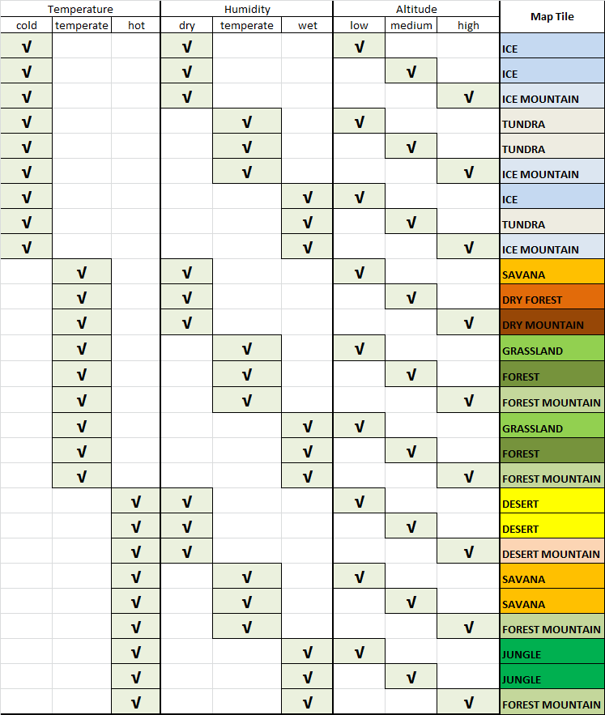 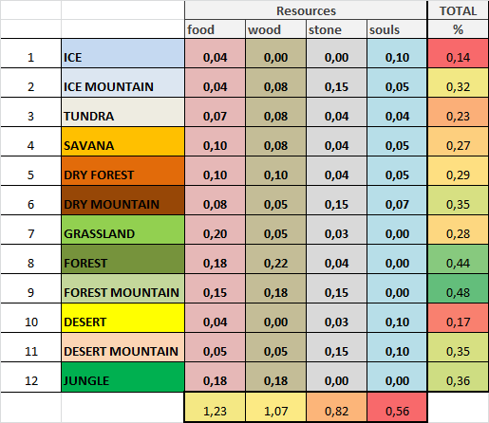

Table 01 Table 02

The Resources

In Before Legends the Hero can find 4 different types of resources as he explores the map:

* Food:
  + the most frequent resource,
  + present in most types of tiles, rare only in “extreme” environments (eg desert)
  + necessary to avoid starvation (when the counter goes down to zero)

- Wood, easy to find

* + easy to find
  + mostly available in environments that would have trees (such as forest)
  + needed for all Battle Cards

- Stone,

* + on average more rare than the other resources
  + spawns … FILL HERE (ASK TOMA)
  + needed for all Battle Cards

- Souls,

* + the rarest resource
  + spawns mostly in “inhospitable” tiles such as desert or tundra
  + needed for battle cards with supernatural effects (eg Heal or Shield)

Resources as shown as map elements and each occupies one tile. Moving The Hero into a tile with a resource will automatically add the resource to his inventory (visible on the upper right).

* Glory,

A special resource available to the player, glory stands equivalent to the experience that the player gains after defeating opponents in battle and cannot be obtained in any other way. Each opponent type will reward to player with different amount of glory, depending on the difficulty level of the opponent, so obviously the stronger the opponent and thus the risk for the player, the higher the amount of glory that can be received after defeating the opponent. The glory is not only essential for the victory condition “Path to Glory”, but also allows the further level progression for the player. Every next level gives significant bonus to the attack, damage and HP stats of the player’s unit, thus making him stronger in battle.

## The Battle Map (Tactical)

Combat Mechanics

When the player attacks an opponent, or is being attacked by one, the game is switched to the combat screen, which is a different layer than the one from the world map:

|  |  |
| --- | --- |
| World Map | Combat map |
|  |  |

The combat map layer of the game is also turn based with the player always having the first move. The player can chose between six actions represented by the six combat cards in the bottom side of the screen. The first action is the basic attack of the player’s unit and has no limit on how often it can be used. All other five actions are however limited and spent by use. Special combat cards can be acquired by the player in the shop in the world map by spending resources. After every action of the player, there is a reaction from the opponent. All opponents have, beside their standard attacks, special actions too, which are triggered by the AI under various conditions, in order to provide great variety for the player during combat.

The UI is designed to offer the player maximum information on the battle at any time and with one glaze over it. Damage is always shown after an attack is executed, the HP’s and the combat stats of both the player’s and opponent’s units are always visible in the left and right corner of the screen and in the bottom right corner of the screen the player has the option to open and close a battle log containing detailed information on every action/reaction during battle, if the player wishes more detailed feedback.

Standard components

AS (Attack skill) “The skill of a unit to successfully attack and injure the enemy”

DS (Defense Skill) “The skill of a unit to protect himself from the attack of the enemy”

D (Damage) “The basic level of injury the unit can cause with his weapon on the health of the enemy unit”

A (Armor) “The physical protection of a unit from the damage inflicted by the enemy in his attack. Armor has a negative correlation with AP.”

HP (Hit points) “The amount of inflicted damage a unit can take before being killed”

AP (Action points) “How many activities can a unit perform within 1 turn during battle. A combination of initiative, Stamina, Skill and motivation. Has correlation to the Speed of the unit. Is required and consumed when committing standard and special attacks.”

S (Speed) “How many map tiles on the tactical map can a unit move during his turn. Cost of move on the APs of the unit.”

Critical Strike

Critical Block

Combat steps and formulas:

MAD (Multiplication on damage (D)) “The success of the attack of a unit in relation to his AS vs the DS of the enemy. Has impact on the D.”

MAD = (AS / DS)/10

if AS > DS , then MAD = (+)

if AS <= DS, then MAD = (-)

DV (Damage Value) “The value of the damage from an attack in relation to the MAD”

DV = D + (D x MAD)

HPP (Hit points penalty) “The final value which will be subtracted from the HPs of a unit after he is attacked. Defined by the DV in relation to the A.”

HPP = [DV / (DV + A)] x DV

## Obstacle & Opponents

*Excel list enemies*

## Player Progression & Pacing

*Excel Levels Olaf*

## Setting & Story

*Brief description intro*

## Visuals

*Interview artist*

### User Interface

## Music & SFX

*Interview Vik*

## Target Group & Platform

Remember about

* Board game/card player

## Team Size & Structure

## Tools & Middleware

## Timeframe & Critical Points